**My Profile**

The project is to elaborate a profile web page that could have 10 pages with 4 look and feel for large screen and 4 look and feel for small screen (depending on the profile from the person. Example: If the person does not have awards then this page would not exist). The sections are mentioned in the pictures.

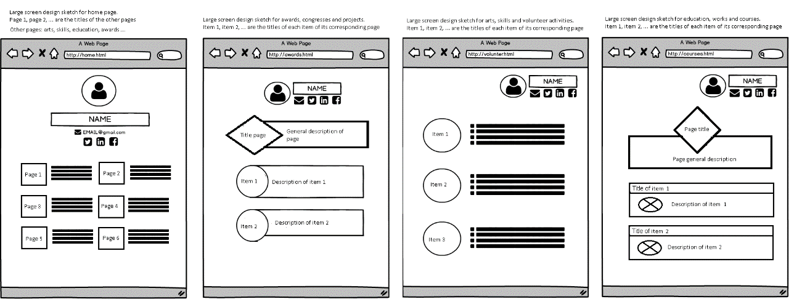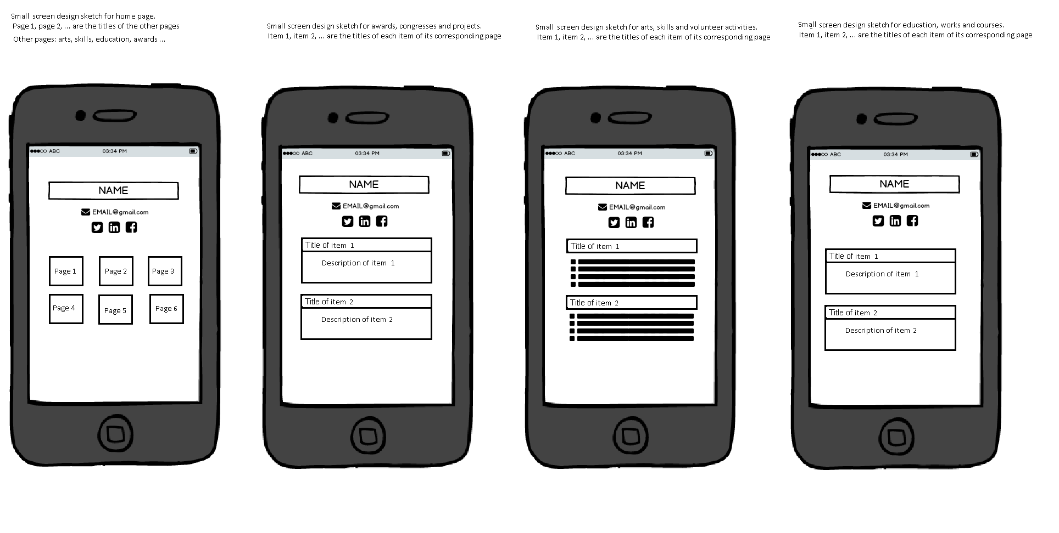

The project is developed with bootstrap and AngularJS. AngularJS allowed me to translate the content of my page easily. Also, I was curious about it and decided to give it a try.